

**BAHIRDAR UNIVERSITY INSTITUTE OF TECHNOLOGY**

**Department; Software engineering**

**Course; operating system and system programming**

**Title ; installation manual guide for Salix operating system**

**Name Rediet Yilma**

**Id 1307210**

**Submitted to lecturer wendemu**

**Submission date 15/11/2014 e.c**

Introduction

An operating system (OS) is the program that, after being initially loaded into the computer by a boot program, manages all of the other application programs in a computer. The application programs make use of the operating system by making requests for services through a defined application program interface (API). In addition, users can interact directly with the operating system through a user interface, such as a command-line interface (CLI) or a graphical UI (GUI). Common desktop operating systems include the following:

**Windows** is Microsoft's flagship operating system, the **de facto standard** for home and business computers. **Mac OS** is the operating system for Apple's Macintosh line of PCs and workstations. **Unix** is a multiuser operating system designed for flexibility and adaptability. UNIX was one of the first operating systems to be written in the C language. **Linux** is a Unix-like operating system that was designed to provide PC users a free or low-cost alternative. Linux has a reputation as an efficient and fast-performing system

In this paper we will talk about one of the Linux operating system Salix **which is Slackware-based Linux distribution** that is simple, fast, easy to use and compatible with Slackware Linux.Salix OS is a Linux Distribution based on Slackware that retains full backwards compatibility with its illustrious parent. However, while the KISS principle that Slackware adheres to refers to the viewpoint of system design, Salix OS also applies it to the viewpoint of the end user.

**Salix Features**   
✔ one application per task rationale  
✔ fully backwards compatible with Slackware  
✔ Optimized for desktop usage  
✔ With Salix tools to assist system management  
✔ High quality package repositories with dependency

Software and hard ware requirements for Salix

**Minimum system requirements**

**RAM:** 512 MB

**CPU:** Intel Pentium III 1 GHz

**Hard drive:** 8 GB

**Desktop / Window manager;** MATE, KDE, Xfce, Fluxbox, Openbox

**Based on;** Slackware

**Project manager;** slapt-get

**Image size;** 613 MB (Fluxbox), 852 MB (MATE live),

**Purpose;** Desktop

**Latest release year; 2016**

**Used virtual box ;** VMware workstation v16

Installation

**Step 1: downloading Salix OS**

1.1 Salix os are free on internet so it easy to download using their website and write Salix operating system

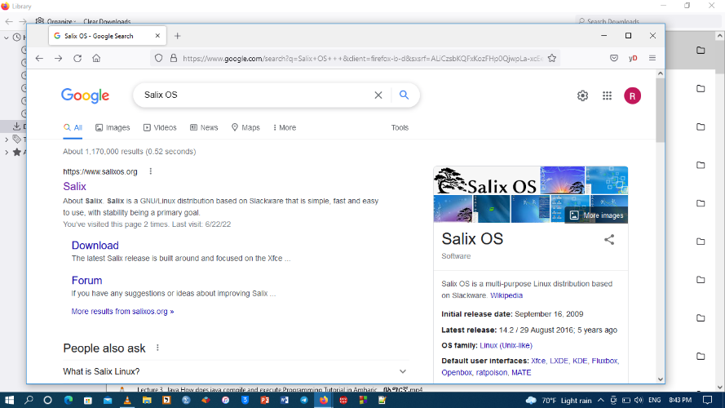

1.2 get in to the website and click downloads then this page will be opened

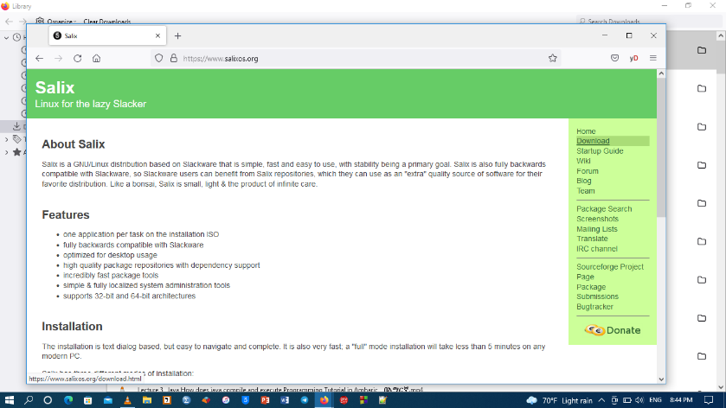

1.3 After we go to download this page will appear.

For your information this option tells us to choose our system type and also the way of downloading in our case system type of my computer is X64 so and I want to download it directly from the source so we are going to choose the second option

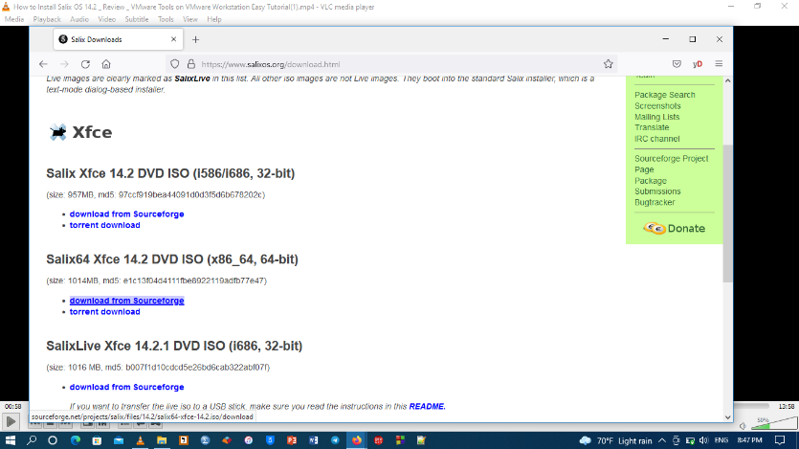

1.4 The Salix os downloaded archived as ISO image files from the Salix OS

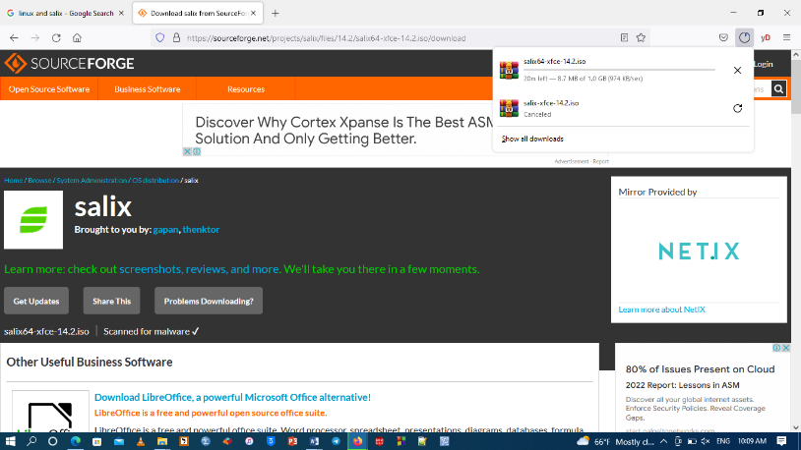

**Step 2: downloading virtual box**

we will be going to install Salix os on window 10 as additional operating system on our computer it will be used as a default operating system in order to do this we are going to need a software that will help us to have more than one operating system on our computer such oracle VM , VMware and others.

VMware Virtual Box is cross-platform virtualization software. It **allows users to extend their existing computer to run multiple operating systems including Microsoft Windows, Mac OS X, Linux, and Oracle Solaris, at the same time**

2.1 type the name on your internet explorer “VMware” and get in to the website that says VMware virtual box

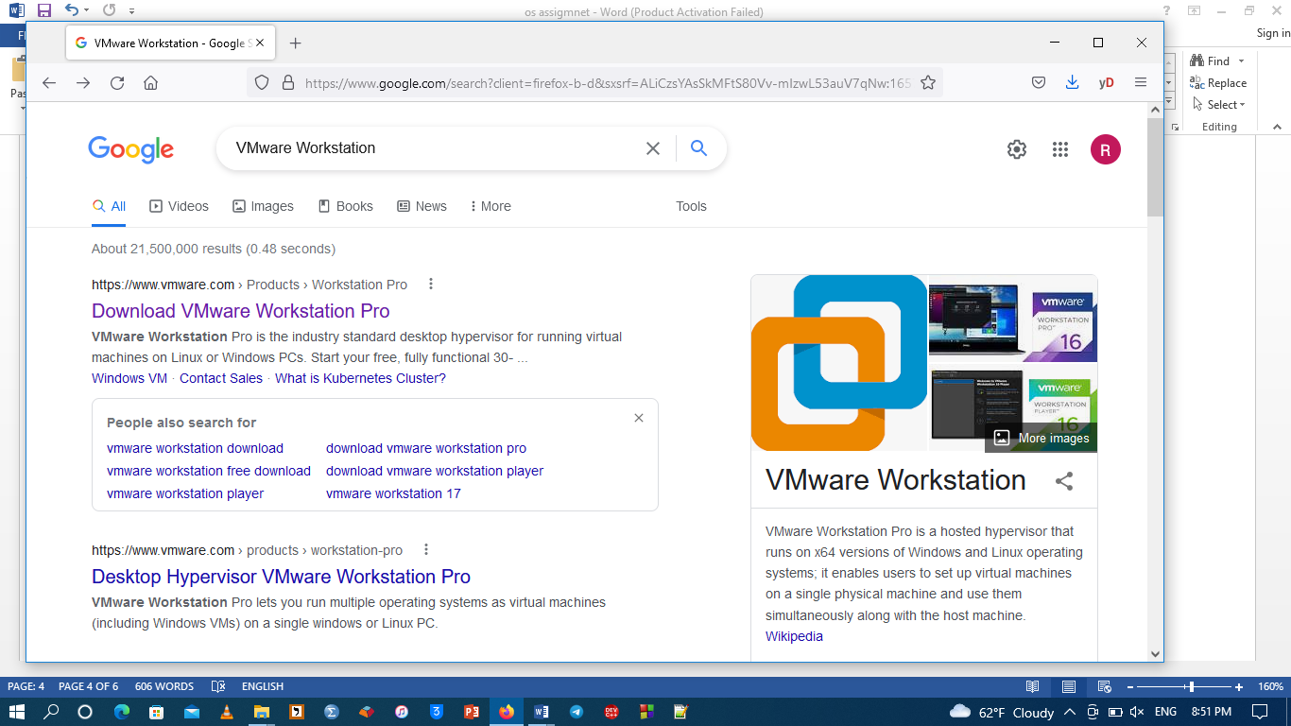

2.2 click on downloads

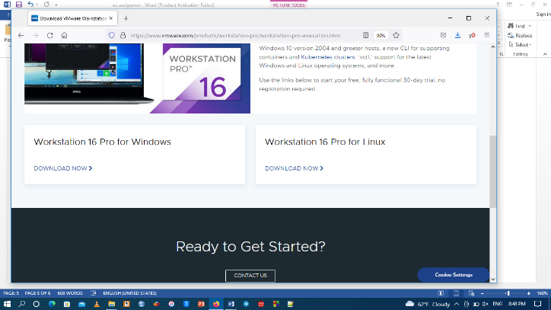

2.3 Then from the download option choose the window option we are using window operating system and download will start.

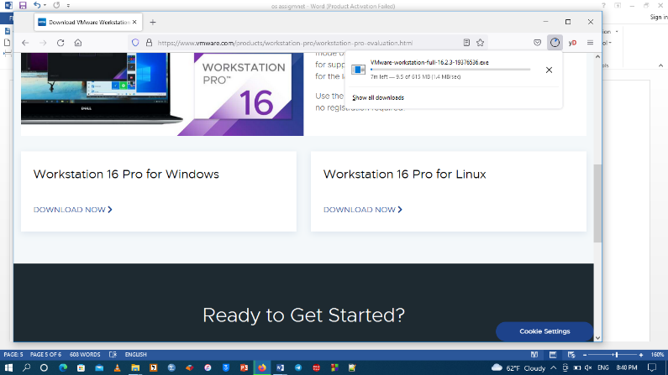

2.4 for installation we go to the download file and click on oracle VM and install

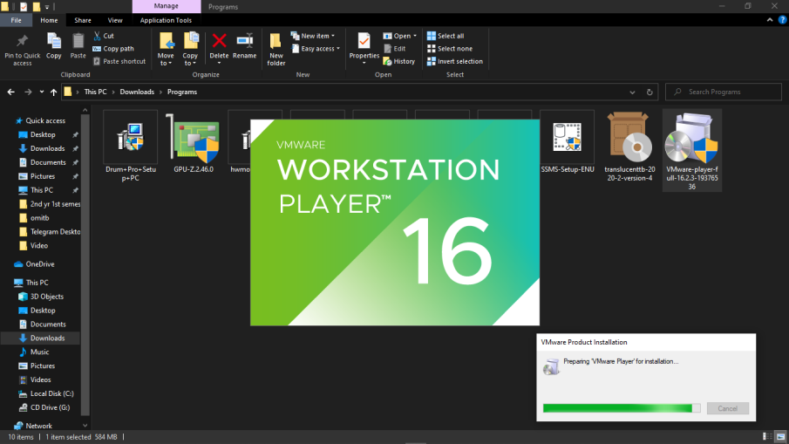

**Step 3: opening Salix on VMware**

3.1 open VMware workstation on your computer then click on create new machine

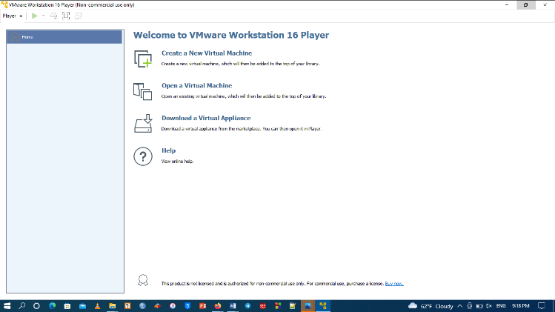 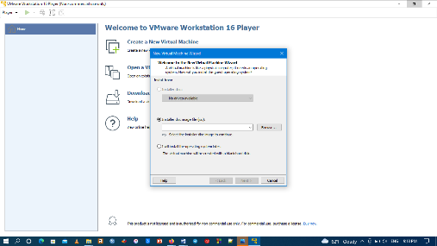

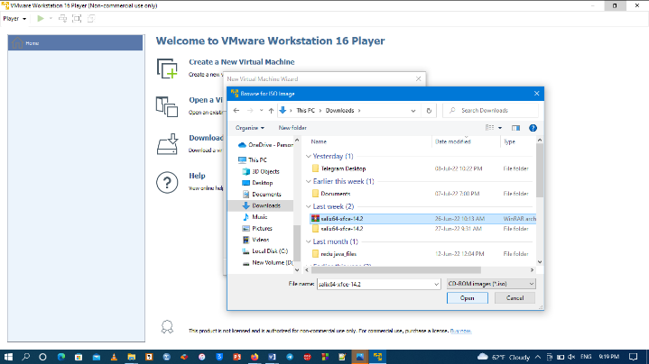3.2 click on the browse and add the iso file for Salix that we have downloaded then next.

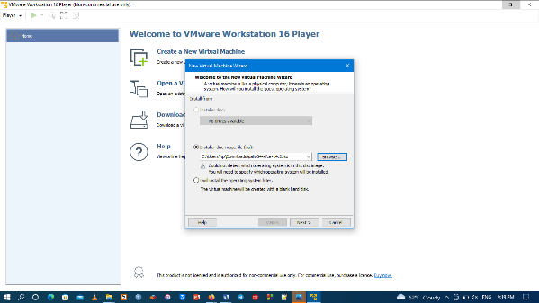

3.3 add the type of operating system in our case Linux

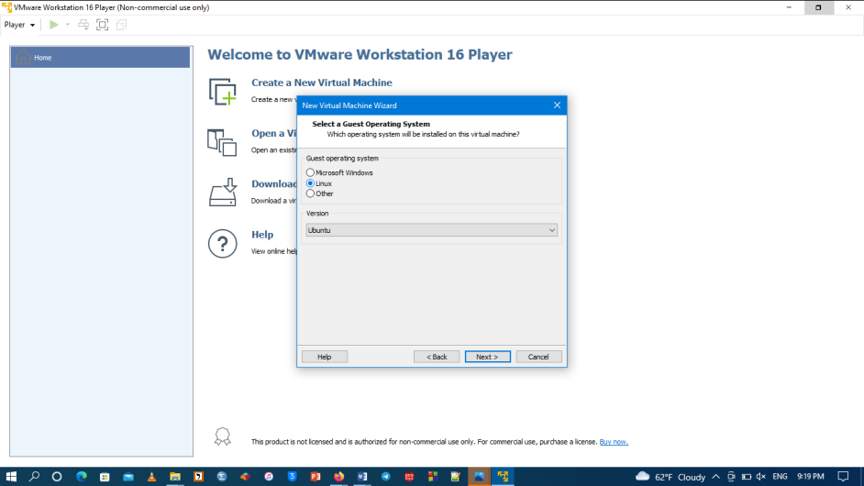

3.4 add the name for the operating system you are going to install in our case it is Salix

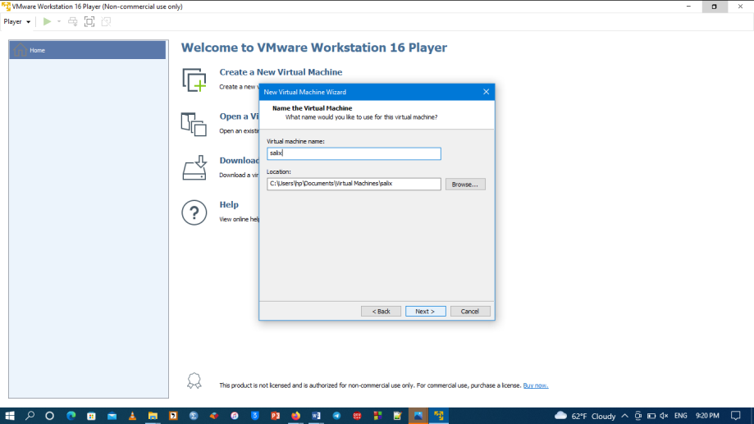

3.5 click on the customize hard ware and add the following

1 set the processor 2

2 set the ios file on the CD/DVD option

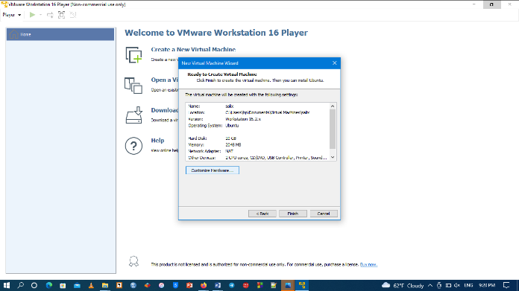 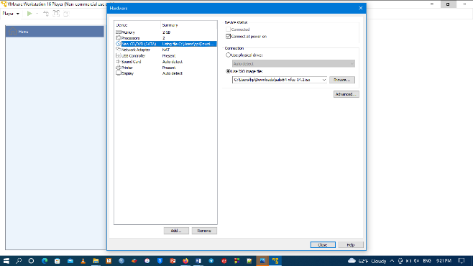

3.6 The click paly the virtual machine

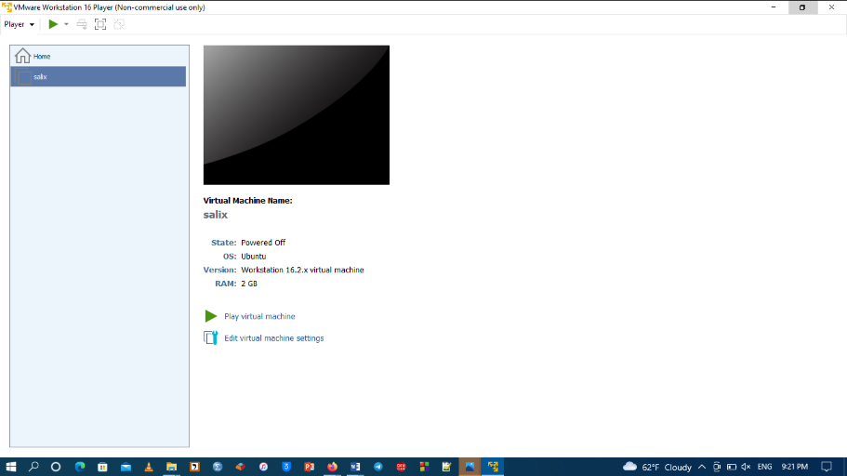

**Step 4 installing Salix**

4.1 select language and click enter next click on select to continue installing

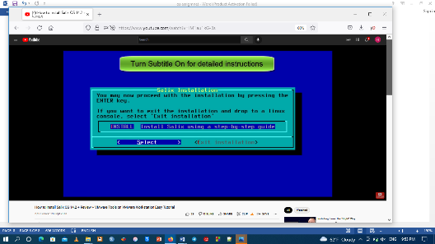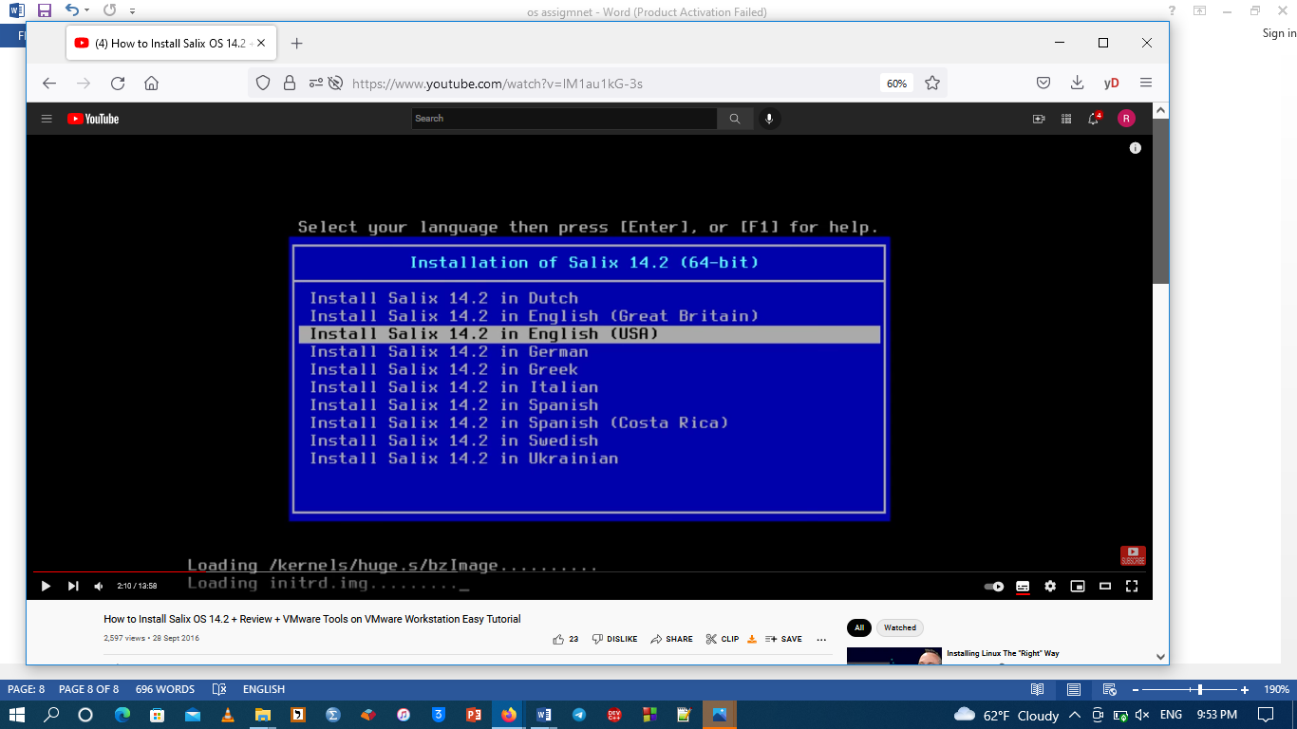

4, 2 click on “space” then enter to set partition

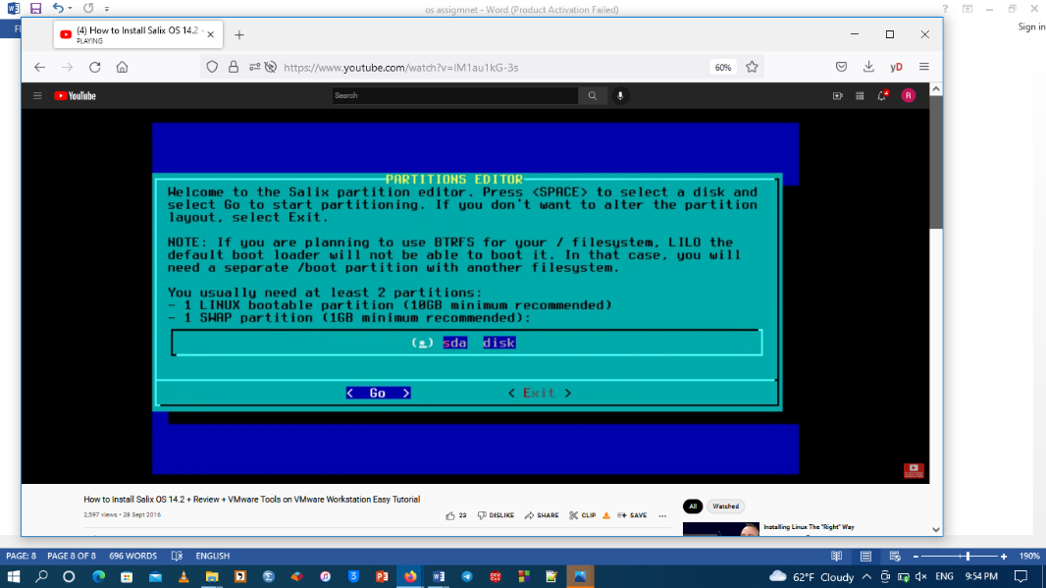

4.3 then set a new the partition and the partition type makes it bootable

“We need .to have atleast 1 bootable with Linux type with 10 GB

And another partition with type swaps and with 2 GB space”

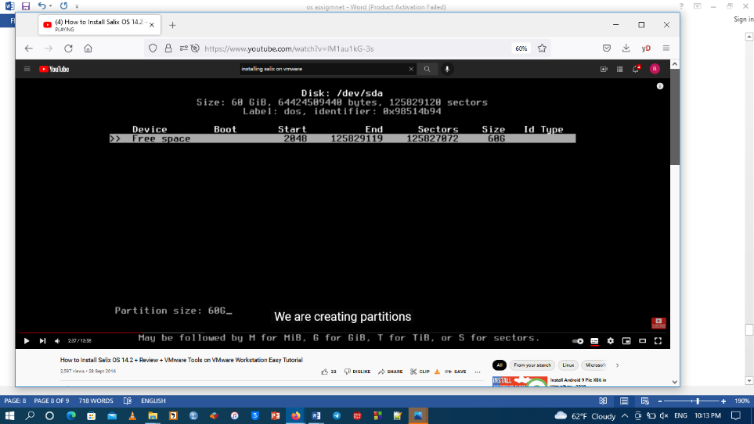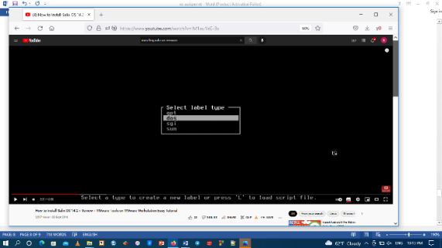

4.4 clicks on enter and then finish the partition

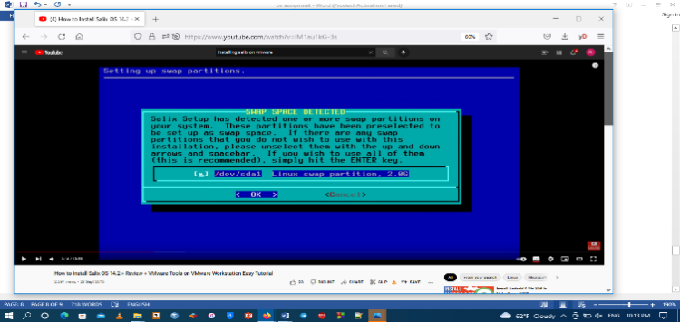

4.5 select file system ext4 which is the updated form of ext3

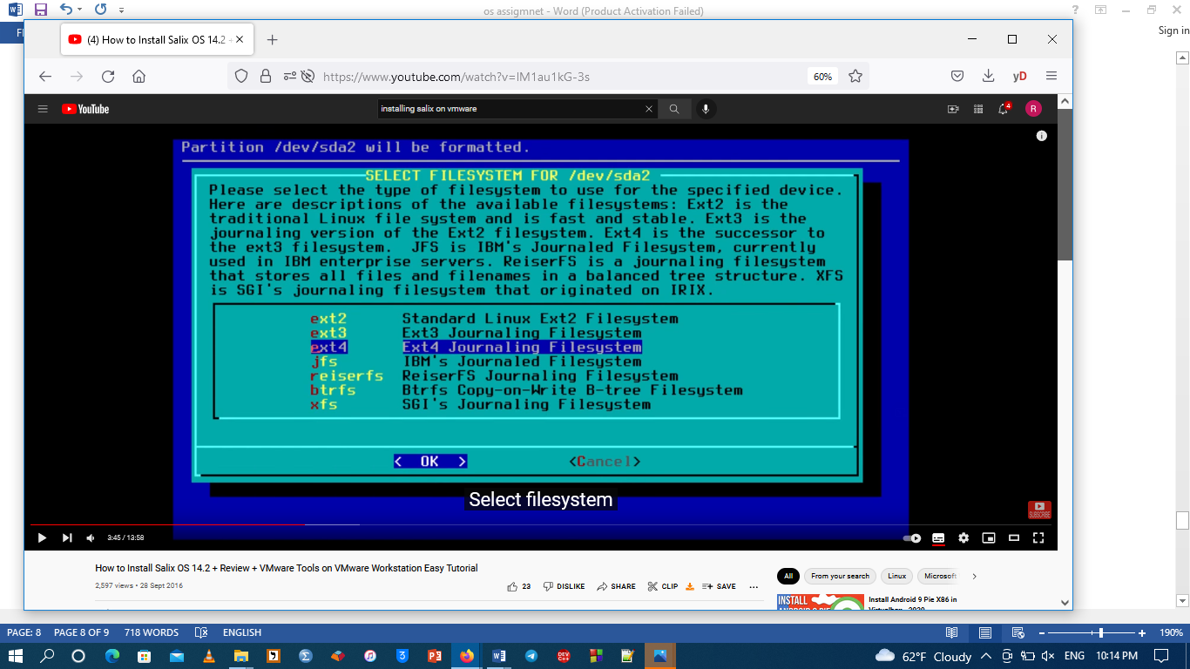

4.6 select installation source from CD or DVD

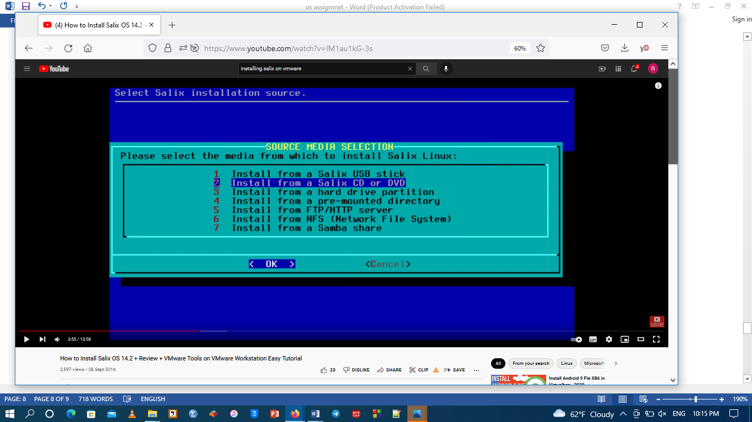

4.7 then select scan option to check if our file exists or not.

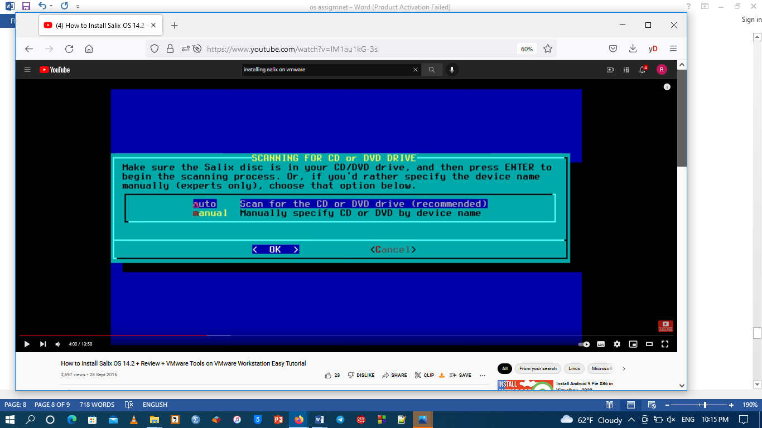

4.8 click on install everything to start the final installation process

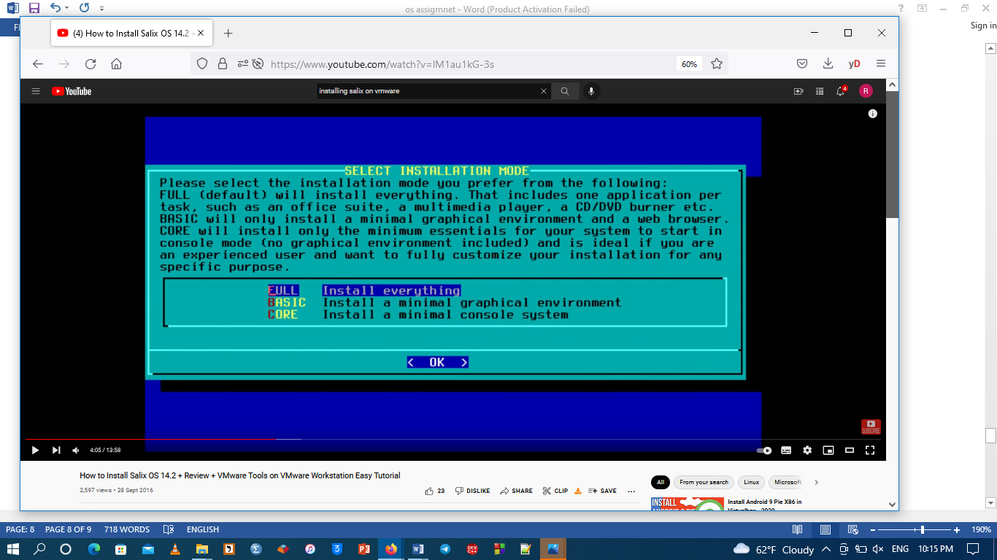

4.9 installation begins

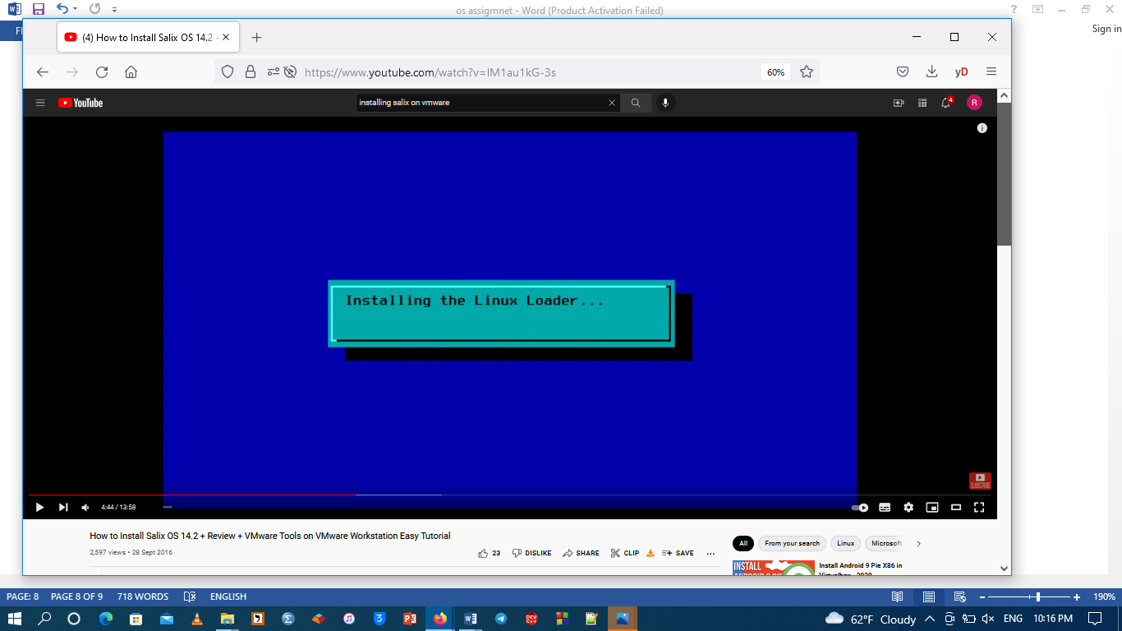

The final result of our Salix operating system will look like this

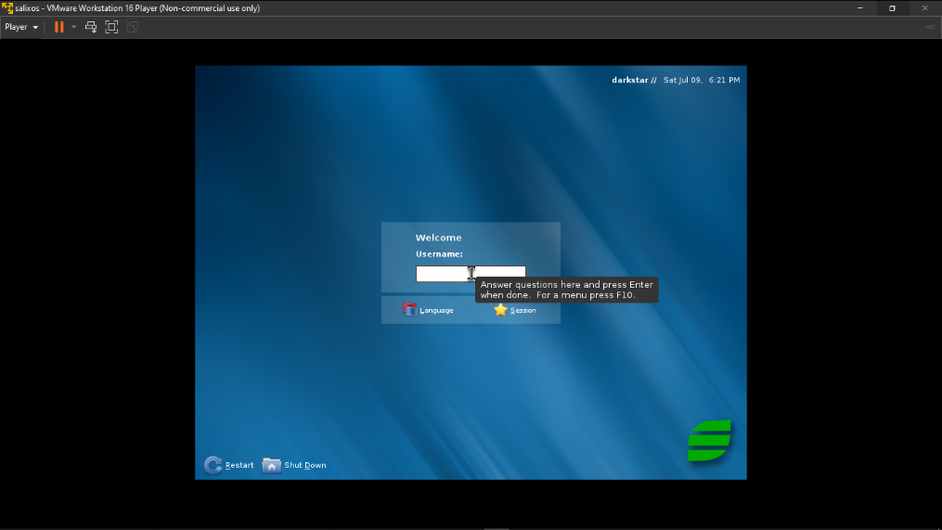

Successfully opened

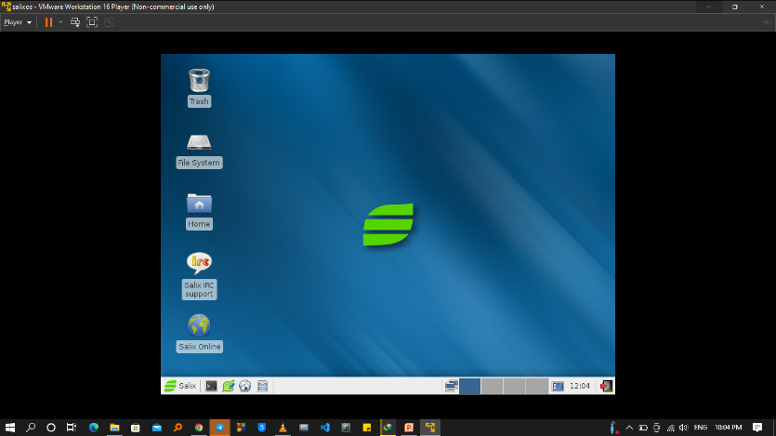

**Adding application on Salix operating system**

**Adding an application software in to Salix is the treated as installing packages since Salix is an older operating system it doesn’t have a unique application software that can download and install application so we are going to use the command to install the application but first before using commands in our command we need to update our system packages using gslapt or sorcery**

**Commonly used commands**

**Slapt-get; download, install and update Slackware packages**

**Slapt-src; to download, install and update slack builds**

**Spkg; for installing documents in our file**

**Try to download your files based on Slackware distribution if possible!**

**Telegram**

1 Downloading Telegram

Search telegram messenger for Linux and download the file

2 Then to install to our telegram application

2.1 go to terminals holding the downloaded file directory and install using

Sudo slapt-get install telegram

**Problem:** in our case this command did not work because the downloaded file was archived and need to be extracted first

**Solution**; we use the command

tar –xvJf ./tsetup.4.0.2.tar.xz // this command will extract and create a binary file our folder.

2 go to the binary file and double click the file and it will start to run

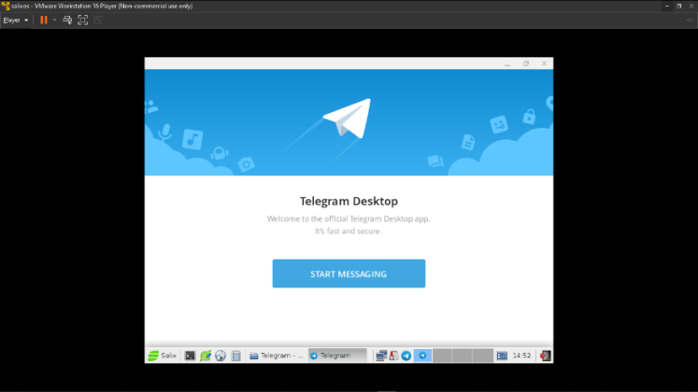

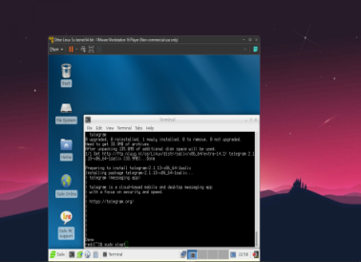

**2 installing NetBeans**

1 Downloading net beans for Linux on our internet explorer

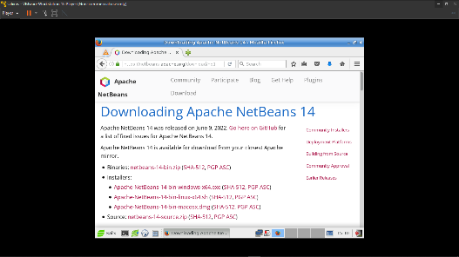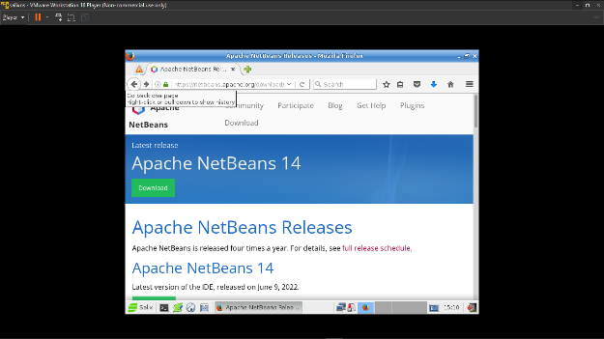

2 Install the file using commands

Caution; net beans needs jdk file to be installed in order to work properly

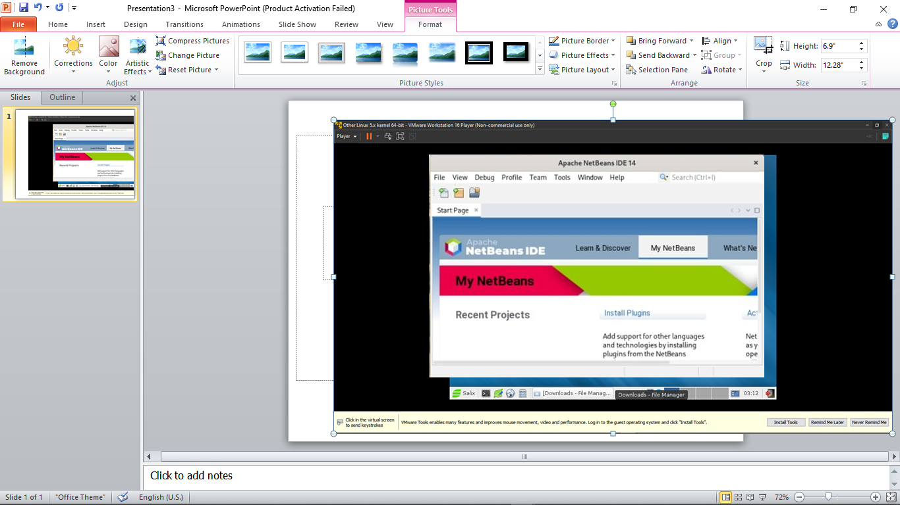

3 installing visual studio

1 download the visual code from internet

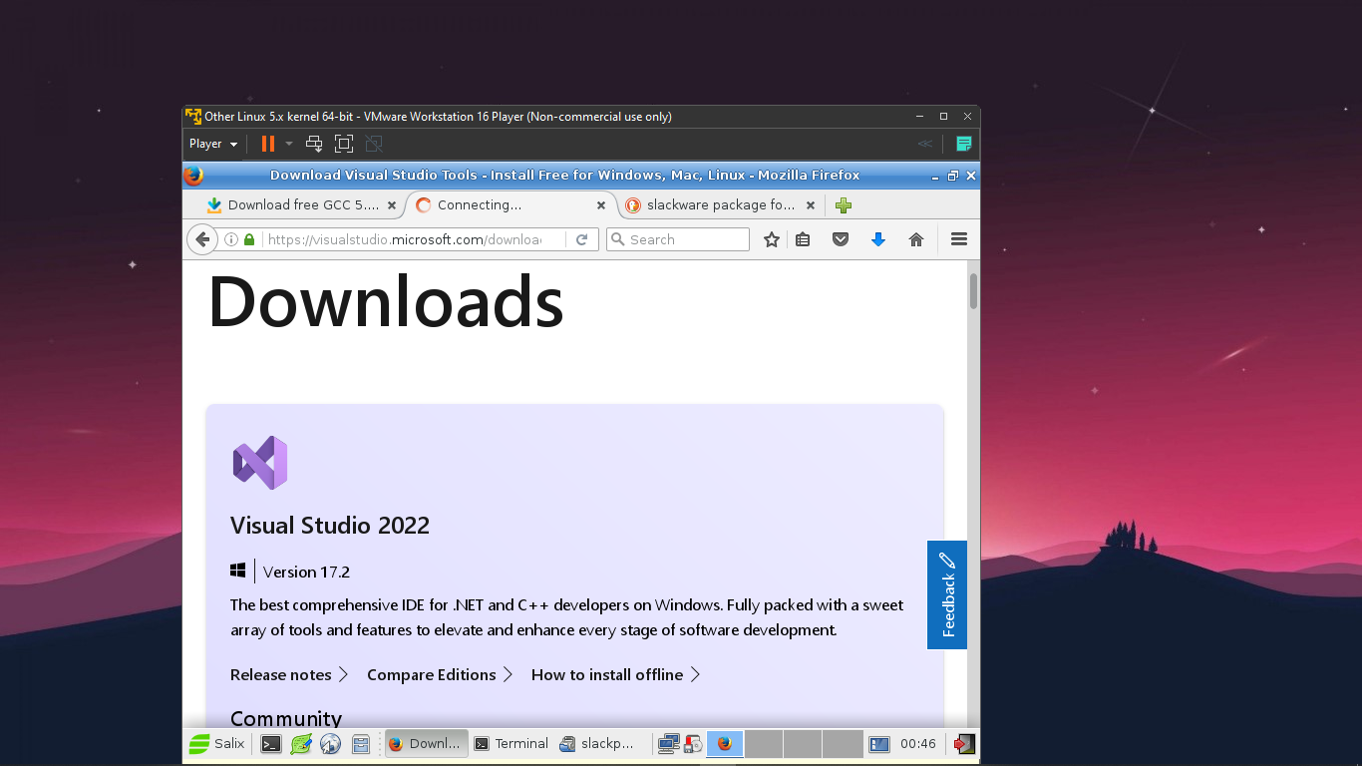

2 install the downloaded file using terminals

**Problem;** after installation of telegram on our guest operating system the previous problem has occurred again and decided to use the same pattern to solve this problem but this time our downloaded file or application file extension was .deb so we need to extract deb file using terminal

**Solution;** to extract the deb file we use the command

For installing .dep extension files first we need to have a Slackware package called dpkg so using this package we can extract and install debian based files

Command; Sudo dpkg –I downloadedfile.deb

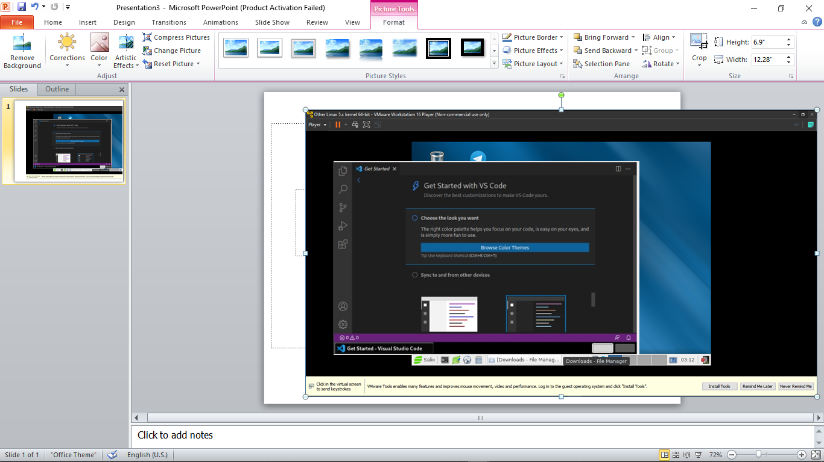

4 Installing Vic media player

1 downloading Vic

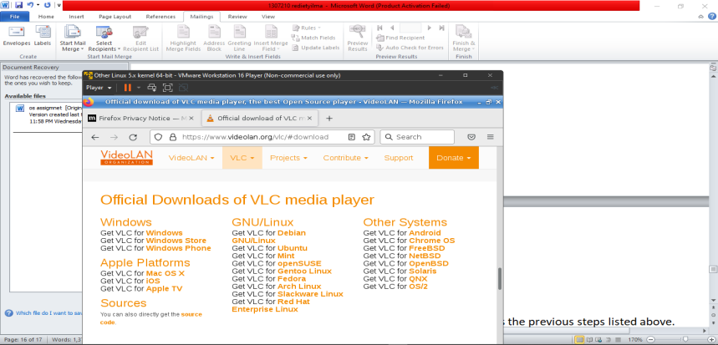

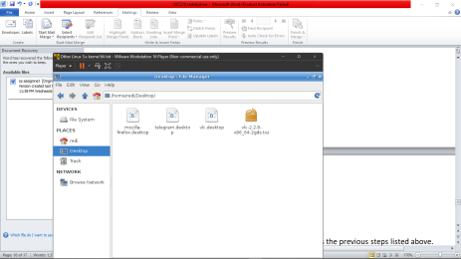

2 installing using the command

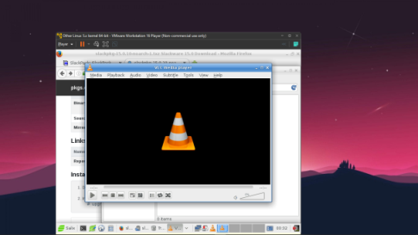Sudo spkg –I our downloaded file.tar.xz

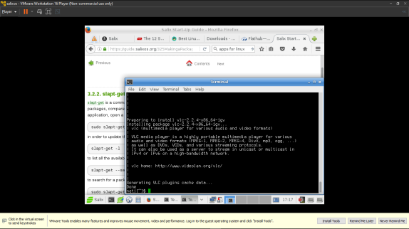

Conclusion

Installation os operating system as a guest operating system follows the previous steps listed above. Having a guest operating system will allow us to have a Salix as our guest operating system Salix is a GNU/Linux distribution based on Slackware that is simple, fast and easy to use, with stability being a primary goal. Salix is also fully backwards compatible with Slackware, so Slackware users can benefit from Salix repositories, which they can use as an "extra" quality source of software for their favorite distribution

Salix os does not have the source package and stack builder automatically active in it so it makes it hard to add applications on our Salix operating system through this installation process the backward of this os system cost much time more than expected although the stat up guide have a great contribution on solving and guiding through all the steps we have performed earlier if in case you got in to some problems while installation I recommend you to use this guide

Resource

1;https://www.google.com/url?sa=t&rct=j&q=&esrc=s&source=web&cd=&cad=rja&uact=8&ved=2ahUKEwirvszggf34AhUE_BoKHVAcBG0QuAJ6BAgQEAc&url=https%3A%2F%2Fwww.youtube.com%2Fwatch%3Fv%3DlM1au1kG-3s&usg=AOvVaw2VaT3CspMQ0E0zhOAj6geq

2; <https://instapdf.in/linux-commands-list/>

3; https://www.salixos.org/guide.html